Three Lever Classes
by Ron Kurtus (revised 26 July 2016)
There are three types or classes of levers, according to where the load and effort are located with respect to the fulcrum. Since humans usually provide energy to levers, "effort" and "load" are often used instead of input and output.
Class 1 has the fulcrum placed between the effort and load. Class 2 has the load between the effort and the fulcrum. Class 3 has the effort between the load and the fulcrum.
Each has its own uses and advantages.

Class 1 lever
A Class 1 lever has the fulcrum placed between the effort and load. The movement of the load is in the opposite direction of the movement of the effort. This is the most common lever configuration.
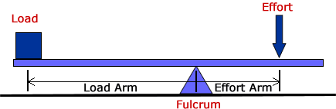
Class 1 lever
The effort in a class 1 lever is in one direction, and the load moves in the opposite direction.
Note that the length of the effort arm can be greater than, equal to or less than the length of the load arm in a class 1 lever.
Examples of class 1 levers include:
- Teeter-totter
- Oars on a boat
- Catapult
- Shoehorn
- Scissors
- Pair of pliers

Double Class 1 lever
A scissors and a pair of pliers are considered a double Class 1 lever.
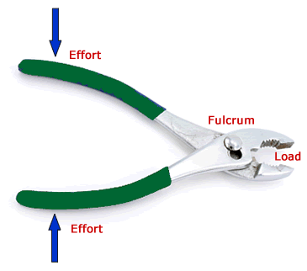
A pair of pliers is a double class 1 lever

Class 2 lever
A Class 2 lever has the load between the effort and the fulcrum. In this type of lever, the movement of the load is in the same direction as that of the effort. Note that the length of the effort arm goes all the way to the fulcrum and is always greater than the length of the load arm in a class 2 lever.
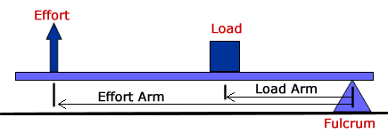
Class 2 lever
The load in a class 2 lever moves in the same direction as the effort.

Examples
Examples of Class 2 levers include:
- Wheelbarrow
- Crowbar
- Nut cracker
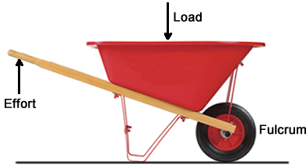
Wheelbarrow is Class 2 lever

Class 3 lever
A Class 3 lever has the effort between the load and the fulcrum. Both the effort and load are in the same direction. Note that the length of the load arm goes all the way to the fulcrum and is always greater than the length of the effort arm in a Class 3 lever. Also, load in a Class 3 lever moves in the same direction as the effort.
Because of the location of the effort with respect to the fulcrum, often a bearing or other device is needed to hold the beam in place as it pivots. Otherwise, the effort will pull the arm off the fulcrum
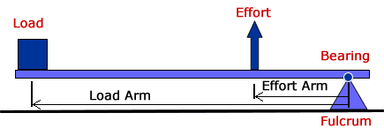
Class 3 lever
An alternative configuration is to have the fulcrum above the arm. However, it still might need a bearing to prevent the arm from falling to the ground:
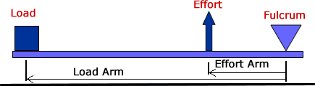
Class 3 lever with fulcrum at top

Examples
Examples of Class 3 levers include:
- Tweezers
- Stapler
- Mousetrap
- Broom
- Hockey stick
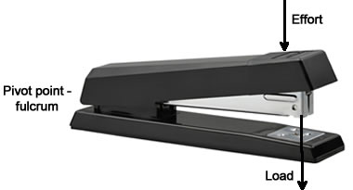
Stapler is Class 3 lever

Summary
There are three types or classes of levers, according to where the load and effort are located with respect to the fulcrum. Class 1 has the fulcrum placed between the effort and load, Class 2 has the load in-between the effort and the fulcrum, and Class 3 has the effort between the load and the fulcrum

