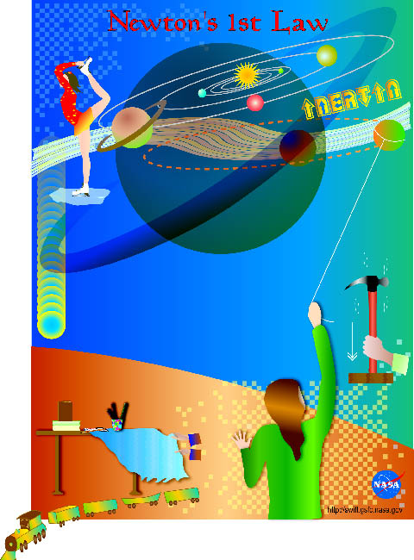
Teacher Information
Teachers: This material examines Newton’s First Law of Motion in a way that will help you teach the law to your students. The photocopy-ready Student Activities pages will give students the opportunity to learn aspects of the First Law in a way that they will find interesting and fun. Notes about each activity appear in the Notes to Teachers section. The activities can be tailored for the level of your students, and can be completed individually or in groups. In addition, students will create a logbook, called Newton’s Lawbook, in which they can take notes and track their findings from the scientific experiments offered in the Student Activities pages.

Newton’s First Law of Motion
In the absence of a net force, a body at rest remains at rest, and a body in motion remains in motion indefinitely along the same straight line.

Newton’s Laws apply to macroscopic systems – things you can feel and see. There are extreme environments for which Newton’s Laws (or Classical Mechanics) only provide an approximate answer, and more general physical laws must be used. For example, black holes and objects moving at nearly the speed of light are more accurately explained by General Relativity, while “subatomic particles” are explained by Quantum Mechanics.
 | Sir Isaac Newton (1642-1727) established the scientific laws that govern 99% or more of our everyday experiences – from how the Moon orbits the Earth and the planets orbit the Sun to how a hockey puck slides over ice, a person rides a bicycle, or a rocket launches a satellite into space. Newton’s Laws are considered by many to be the most important laws of all physical science. They are also a great way to introduce students to the concepts, applications, vocabulary, and methods of science.
Newton’s Laws are related to the concept of motion: Why does an object move like it does? How does the object accelerate or decelerate? To understand these things, we need to understand the relationship between force and motion.
Forces can cause motion. But what exactly is a force? We can think of a force as a push or a pull. A force has a direction as well as a magnitude. A force is a vector quantity which follows the rules of vector addition and subtraction. In a diagram, a force can be represented by an arrow indicating its two qualities: The direction of the arrow shows the direction of the force (push or pull). The length of the arrow is proportional to the magnitude (or strength) of the force.
Historical Perspective
Built upon foundations laid primarily by Aristotle and Galileo, Sir Isaac Newton’s First Law of Motion explains the exact connection between force and motion.
Aristotle theorized that a force is required to keep an object in motion. He believed that the greater the force was on a body, the greater the speed of that body. His theory was widely accepted, since it basically chimed with life’s everyday experiences. Aristotle’s theory remained largely undisputed for almost 2000 years, when Galileo came to a different conclusion.
Galileo believed that it was just as natural for a body to be in horizontal motion at a constant speed as it was for it to be at rest. Of course, it took a genius like Galileo to imagine a “perfect world” – one without friction – in which such a conclusion would be true.
Isaac Newton built upon Galileo’s ideas. In his work known as “Principia,” published in 1687, Newton readily acknowledged his debt to Galileo. His First Law of Motion stated: A body continues at rest or in motion in a straight line with a constant speed until acted on by a non-zero net force. The tendency of a body to maintain its status quo is called inertia. Newton’s First Law is often referred to as the Law of Inertia.
The Swift Satellite
Swift is a space-based multiwavelength observatory dedicated to the study of gamma-ray bursts. Its purpose is to determine the origin and nature of these powerful cosmic explosions; determine how the blastwaves from the bursts evolve and interact with their surroundings; and determine if these bursts can be used as effective probes of the early Universe. Scheduled for launch in Fall 2003, Swift is a collaboration between the United States, the United Kingdom, and Italy.
Newton’s First Law and the Swift Satellite
Swift will orbit the Earth about 600 km (350 miles) above us. It will travel at a speed of about 7,600 meters per second (17,000 miles per hour). According to Newton’s First Law, if Swift were to reach deep space, far away from the gravitational pull of any planets or stars, it would travel in a straight line and at the same speed, forever. Without the influence of gravity, there would be nothing to cause Swift to change directions or speed. However, the Earth’s gravitational pull will keep Swift from moving in a straight line, causing it instead to move in a circular orbit around the Earth.
Demos and Thought Problems
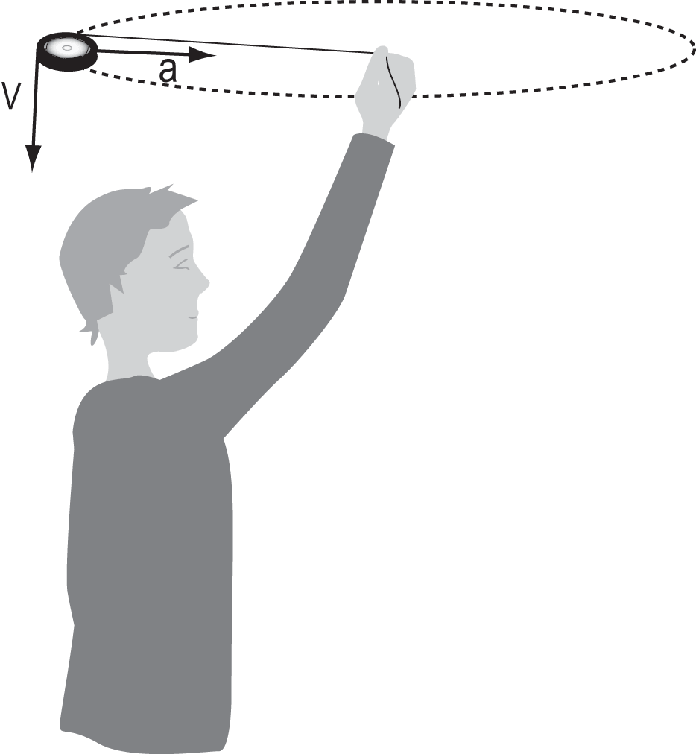 |  | Teachers: Use the following demonstration to introduce Newton’s First Law to your class.  Whirl a yo-yo around on the end of its string. Explain that the string’s tension (created by the pull of your hand) is the force which allows the yo-yo to move in a constant circular path. If you let go of the string, the yo-yo will fly off in a straight line tangent to the point on the circle where it was let go. Again, this is consistent with Newton’s First Law. (Note: For safety purposes, you might consider attaching a string to a Nerf ball, whiffle ball, or bagel.)
Student Activities
Students: These activities will help you learn all about Newton’s First Law of Motion. Find a notebook that you can designate for this project. On the cover write: Newton’s Lawbook. In it, you will take notes, track your progress, and evaluate findings from the experiments you will conduct. Start by writing down Newton’s First Law of Motion.

Newton’s First Law of Motion
In the absence of a net force, a body at rest remains at rest, and a body in motion remains in motion indefinitely along the same straight line.

Activity #1: Inertia – A Body at Rest
In this experiment you will learn about inertia. In it, you will try to remove a bookcover from under an object without moving the object on top. Magicians do this all the time. Remember seeing a magician pull a tablecloth out from under a pile of dishes? Was it magic or science?
Before you begin, write down in your Newton’s Lawbook what you think will happen. Try to explain the scientific reasons for the outcome you predict.
Materials
You will need the following items for this experiment:
• one bookcover or large piece of smooth paper
• one book with a hard, glossy cover
• one book with a rough or non-glossy cover
• objects to place on the bookcover
Procedure
1. Place the bookcover (or piece of paper) on a flat, smooth surface.
2. Put the book with the glossy cover on top of the bookcover.
3. Quickly (and in one smooth motion) yank the bookcover out from under the book.
4. Write down what happens.
5. Do the experiment again, this time putting other objects on top of the bookcover. Observe what happens and write your answers to the following questions in your Newton’s Lawbook: Does mass (weight) have any effect on the experiment? Does the type of object you add have any effect? If so, in what way and why?
6. Try the experiment again using a book with a rough or non-glossy cover. What do you notice? Can you explain how this experiment relates to Newton’s First Law of Motion?
Activity #2: Inertia – A Body in Motion
In this experiment you will try to drop a tennis ball on a target as you run past the target. Think it’s easy? Before you begin, try to guess what will happen. Try to figure out when you will need to release the ball in order to hit the target. Write down your predictions in your Newton’s Lawbook. Give the reasons why you think you are correct.
As you conduct this experiment, think of the challenges Air Force pilots had before the invention of the guided missiles that are used today. Pilots in World War II had to understand mathematics in order to drop bombs on targets while causing as little harm as possible to surrounding buildings and people. These are the same concepts that you will learn with this experiment.
Materials
You will need the following items for this experiment:
• one tennis ball
• clearly-marked target(s), i.e., notebook paper, a chalk mark, or tape
Procedure  1. Place a target about 10-15 meters away from a starting line. Mark the starting line with chalk or tape. | 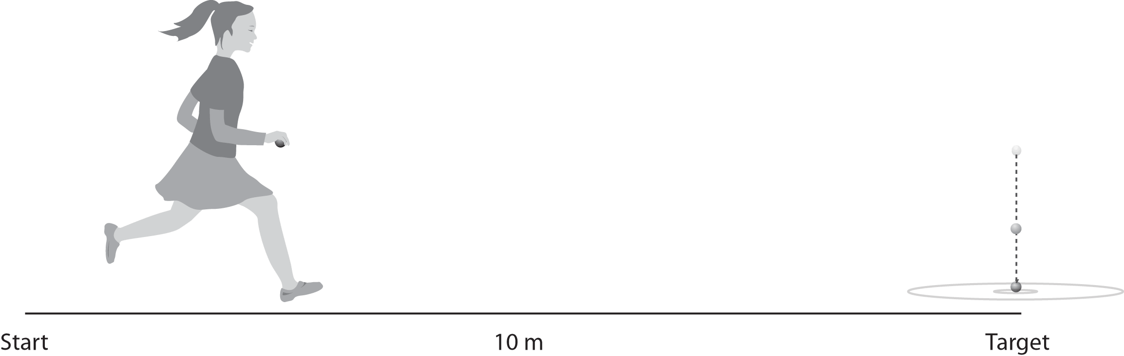
2. Hold the tennis ball and do not let your elbow leave your side as you run and drop the ball. Do not throw the ball. You should hold the ball from its sides so that you can release your grip as you let it drop. Remem-
ber to drop the ball and not throw it, otherwise you will change the intent of the experiment.
3. Have three students stand alongside (but slightly back from) the running path to act as observers. One should stand before the target, one at the target, and one just after the target. Their objective is to determine exactly where the runner released the ball and where the ball strikes the ground.
4. Ask the runner to sprint toward the target as fast as she or he can and try to drop the ball so that it lands on the target.
5. Next, have the observers make a diagram in their Newton’s Lawbook of where the ball was released and where it landed. Repeat the experiment until the ball hits the target.
6. Use the information in Step 5 to predict what would happen if a student ran at a slower speed.
7. Repeat Steps 4-5, using a different runner sprinting at a slower speed.
8. Use the information in the previous trials to predict what would happen at a walking speed.
9. For the last trial, ask a student to walk toward the target. Repeat Steps 4-5.
10. Write a summary of your results in your Newton’s Lawbook. Form conclusions based on the speed of each runner, the location of each ball’s release, and the exact point where each ball landed.
Activity #3: And They’re Off!
This experiment will teach you more about why Newton’s First Law of Motion is also called the Law of Inertia. The method used in this experiment is very similar to one that Galileo conducted.
In this experiment you will discover how Newton’s First Law works by conducting a race with two jars.
Materials  You will need the following items for this experiment:  • two identical jars with lids (either plastic or glass jars)  • flour or sand to fill one of the jars  • iron filings or small lead pellets to fill one of the jars  • two identical, empty three-ring binders (at least 2.5” in width)  • a measuring tape  Procedure |  |  |  | 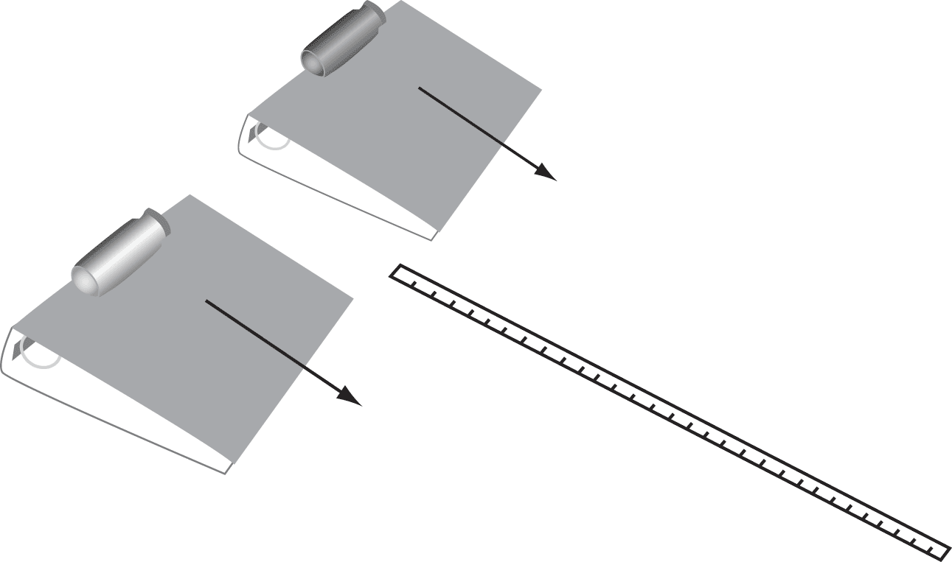
1. Fill one jar with flour or sand. Pack it tightly.
2. Fill the other jar with iron filings or small lead pellets. Again, fill it tightly.
3. Put lids on both of the jars. Lids should be on tight.
4. Place both three-ring binders next to each other on a wooden or tile floor. Place each jar on
its side and release both from the top of the “ramps” at exactly the same time.
5. In the Table below, record how far each jar rolled. Do not measure the binder itself, just the
distance from the end of the binder to where each jar actually stopped.
6. Repeat Steps 3-4 for each of the surfaces listed on the Table.
7. Fill in the Table with your results for each race.
Race | Surface | How far did the  empty jar travel? | How far did the  filled jar travel?
1 | Wooden Floor
2 | Carpet
3 | Linoleum
4 | Tile Floor
5 | Other ( ___________ )

Examine your data to look for trends and record your observations in your Newton’s Lawbook. This will prepare you for the questions that follow. For example, determine if one jar always rolled farther than the other. Look to see which jar rolled farthest on a given surface. Try to figure out why you got the results you did for each jar on each surface.
Think About It
Write the answers to the following questions in your Newton’s Lawbook.
1. Did the results depend on whether the jar was filled with flour/sand versus iron/lead? If so, in what way?
2. Did the results depend on the kind of surface you used? If so, in what way?
3. What can you say about a body’s tendency to maintain its status quo – its inertia?
Activity #4: Rock and Roll?
Rotational or gyroscopic inertia is the inertia of an object rotating on an axis. Just as objects traveling in a straight line will continue to do so, rotating objects (such as tops, flywheels, and gyroscopes) want to keep spinning. The rotational inertia of an object is directly related to its rate of rotation. This means that objects with large rotational inertia will require a large force to change its spin, while objects with small rotational inertia will require only a small force.
Rotational inertia accounts for the stability of gyroscopes and bike-riders, and has applications for navigation of planes and figure skaters performing lightning-fast spins. Here is a simple experiment that will help you understand this concept.
Materials
You will need the following items for this experiment:
• one LP record (or cut foam board or cardboard in a circle with a 12” diameter)
• one of the following: wooden matchstick, pencil, or headless nail
• string
Procedure  1. Tie one end of the string to the middle of a matchstick, pencil, or finishing nail.  2. Pull the other end of the string through the hole of the LP record (or foam board or cardboard). The matchstick, pencil, or headless nail should be centered underneath the LP.  3. Swing the record back and forth like a pendulum. Try to achieve smooth, even movements. Describe what happens in your Newton’s Lawbook. |  |  | 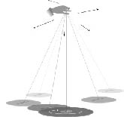
4. Now give the record a spin so it rotates on top of the matchstick, pencil, or headless nail.
5. While it is still spinning, try to swing the record again like a pendulum. Make a note in
your Newton’s Lawbook about what you observe. What do you notice about the angle the
record makes with the ground as it swings along its pendulum arc?
Notes to Teachers
Activity #1: Inertia – A Body at Rest
The book should move little, if at all.
Explain to your students the reasons for the results they have observed. The book did not move because of inertia, which is explained by Newton’s First Law of Motion: A body at rest will remain at rest unless acted upon by an outside force.
Note that the objects move less when friction is reduced. This permits us to see that Newton’s First Law is correct. Your students will notice the objects move hardly at all when the paper is pulled from under the glossy-covered book, and a little more when they pull it from under the book with the non-glossy cover.
Activity #2: Inertia – A Body in Motion
When running, students will miss the target when the tennis ball is dropped directly over it. The ball needs to be dropped before the target is actually reached. As the ball drops, its horizontal motion remains unchanged because there is no force in that direction. Newton’s First Law applies to the horizontal motion. You might have your students start this activity by rolling (or pushing) the ball on the floor, and observing its constant velocity once they let go of it. This is another application of Newton’s First Law of Motion: A body in motion will continue in motion in a straight line unless acted upon by an outside force. In this case, the motion is that of the runner, and gravity is the outside force.
Possible Extensions
• If time permits, try the experiment again using a smaller target. Another idea would be to
try dropping the ball into a bucket, decreasing the size of the bucket with each step.
• If you have access to a digital camera, enhance the activity by filming each runner (with
a wide angle) and the path of each drop. Slow motion of the video will allow your class
to analyze the trajectories.
Activity #3: And They’re Off!
According to Newton’s First Law, each jar will roll in a straight line at a constant speed unless a force acts on it. In this experiment, the jars roll in straight lines because there is no force making them turn to the left or to the right. However, because of friction, they do slow down. Friction is the resistance to motion between two surfaces that touch, i.e., resistance of a body in motion to the air, water, or another medium through which it travels – or to the surface on which it travels. Oil reduces friction. Bodies moving through a vacuum do not encounter friction. A sled moves more easily on smooth ice (which has less friction) than on rough ground.
Your students will make an important observation as they conduct the race on different surfaces, and understand the role of friction in misleading Aristotle and other early scientists. Smoother surfaces create less friction. It is the force of friction which eventually stops objects from continuing to roll forever in a straight line. Galileo was first to realize this. It took his brilliant mind to imagine a perfect world in which there was no friction, and to imagine how things would behave in this world. Before that, scientists couldn’t imagine that motion in a straight line at a constant velocity is just as “natural” as being at rest.
If your class is ready to explore moments of inertia, have them race one of the filled jars against an empty jar. Perform the experiment on both a carpeted and a tile surface. Observe what happens in each case. When the race begins, the filled jar moves down the ramp faster than the empty jar. This happens because its weight is evenly distributed throughout its volume thanks to the material inside. The empty jar’s weight consists only of the jar itself, so it doesn’t roll quite as fast. Scientifically, the empty jar has a greater moment of inertia than the filled jar. The empty jar is essentially a hoop, and the moment of inertia for a hoop of radius R is equal to mR2. The filled jar of radius R is a solid cylinder (or a solid disk), which has a moment of inertia equal to 1/2 mR2. Objects with larger moments of inertia require larger torques to change their rotation rates. So the filled jar (with the lesser moment of inertia) is easier to accelerate and thus reaches the bottom of the incline first. On a tile surface, the filled jar will roll further than the empty jar. But if you allow the jars to roll onto a rough surface such as a carpet, the greater weight of the filled jar causes greater friction between the jar and floor. The filled jar will slow down much faster - allowing the lighter, empty jar to roll farther!
Activity #4: Rock and Roll?
A gyroscope is a device that uses rotation to produce a stable direction in space. A basic gyroscope consists of a spinning wheel or ball, called a rotor, and a support system. Once the rotor is set in motion, the gyroscope resists any attempt to change its direction of rotation. Because of this property, gyroscopes are widely used in flight and navigation instruments. For example, gyroscopes are used to give navigators course information that is unaffected by air turbulence or heavy seas.
Gyroscopic inertia is the property of a rotating object to resist any force that would change its axis of rotation. For example, the Earth spins around its axis (the imaginary line that connects the North and South Poles). Because of gyroscopic inertia, the north axis of the Earth continues to point to the North Star as the Earth moves in its orbit around the Sun. In this experiment, once the LP record is set spinning at an angle perpendicular to the string, it will resist any forces (such as gravity) that try to change its angle.
Gyroscopic inertia enables the axis of a spinning gyroscope to always point in the same direction, no matter how the gyroscope’s support is moved. The magnitude of the inertia depends on the distribution of the weight of the rotor and the speed of its spin. Gyroscopes with most of their weight at the rotor’s rim have the greatest amount of inertia. Thus, a bicycle wheel makes a good gyroscope, but a pencil spinning on its point does not. In addition, the faster the rotor spins, the more gyroscopic inertia it possesses.
Resources
Copies of these materials, along with additional information on Newton’s Laws of Motion and Law of Gravitation, are available on the Swift Mission Education and Public Outreach Web site:
http://swift.sonoma.edu/education/
• NASA Web sites:
NASA’s official Web site - http://www.nasa.gov
Swift Satellite - http://swift.gsfc.nasa.gov
• NASA Education Resources:
Swift’s Education and Public Outreach Program - http://swift.sonoma.edu
SpaceLink, Education Resources - http://spacelink.nasa.gov
Imagine the Universe! - http://imagine.gsfc.nasa.gov
StarChild - http://starchild.gsfc.nasa.gov
• NASA’s Central Operation of Resources for Educators (CORE): http://core.nasa.gov/index.html
Check out these videos:
“Liftoff to Learning: Newton in Space” (1992), $15.00
“Flight Testing Newton’s Laws” (1999), $24.00
• Newton’s Laws of Motion:
http://www.grc.nasa.gov/WWW/K-12/airplane/newton.html
• Newton’s Law of Gravitation:
http://csep10.phys.utk.edu/astr161/lect/history/newtongrav.html
• Conic Sections:
http://www.keypress.com/sketchpad/java_gsp/conics.html
http://cs.jsu.edu/mcis/faculty/leathrum/Mathlets/conics.html
• Newton in the Classroom:
http://www.physicsclassroom.com/Class/newtlaws/newtltoc.html
http://www.glenbrook.k12.il.us/gbssci/phys/Class/newtlaws/u2l1a.html
Acknowledgments
Creators:
Kara Granger, Maria Carrillo High School, California
Laura Whitlock, NASA’s Swift Mission, California
Science and Education Reviewers:
Thomas C. Arnold, State College Area High School, Pennsylvania
Margaret Chester, The Pennsylvania State University, Pennsylvania
Alan Gould, Lawrence Hall of Science, California
Bruce H. Hemp, Ft. Defiance High School, Virginia
Derek Hullinger, University of Maryland, Maryland
James Lochner, NASA Goddard Space Flight Center, Maryland
Jane D. Mahon, Hoover High School, Alabama
Ann Parsons, NASA Goddard Space Flight Center, Maryland
Original Artwork and Design: Aurore Simonnet, Sonoma State University, California
Painting of Sir Isaac Newton by Enoch Seeman, 1726
Editor: Stacy Horn, San Francisco, California
http://swift.sonoma.edu

